**Das, Kamala (Kamala Surayya) (1934-2009)**

Navneetha Mokkil

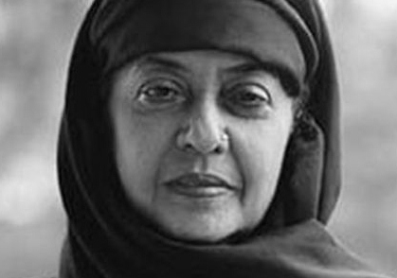

Kamala Das, one of the best-known bilingual writers from India in the twentieth century, consistently pushed the boundaries of what could be represented in literature through her poetry in English, autobiographical writings and novellas in English and Malayalam, and a large body of short stories in Malayalam. Through the conscious deployment of the confessional voice in her poetry and life writings and the intricate entanglement of the public and the private in her fictional worlds, Das carved a space for the explorations of the affective realm and physicality in modern Indian literature.

Kamala Das’s exposure to books and literary production came at an early age through her mother Nalappat Balamaniyamma, a prolific poet, and her maternal uncle Nalappat Narayana Menon, a prominent writer and translator. Many of Das’s writings are set in the milieu of the privileged, Hindu, Nair community in which she grew up in Kerala, and caste is an important vector that shapes narratorial perspective and social encounters in her fiction. At the age of seventeen, she married Madhava Das and moved with him to Bombay. She spent almost three decades of her creative life in cities such as Bombay, Calcutta and Delhi and moved back to Kerala only in 1980. This mobility is reflected in the urban backdrop of many of her writings, even as her narratives are infused with nostalgia for a lost ancestral home and a recurring return to the scenes of childhood. Her conversion to Islam in 1999, and acceptance of the name Kamala Surayya, was a widely debated move within India. She was a hyper-visible public figure in Kerala and her persona was built through her performance of spirited irreverence for social, sexual and religious norms.

She published her first Malayalam story, “Stree” (Woman), in *Mathrubhumi Weekly* in 1947 under the name Kamala. This story, a bold declaration of lesbian love, was not included in her first anthology of short stories, *Mathilukal* (Walls, 1955), published under the pseudonym Madhavikkutty. According to Das, anonymity, masquerade and disguise were literary strategies she used as she “practiced writing as people practice a secret vice. Like boys going to the bathroom to smoke.”

In the 1970s, Das worked for two terms as the poetry editor of the *Illustrated Weekly of India* and thus played an important role in shaping the field of modern poetry in India. Her first poetry collection *Summer in Calcutta* (1965) marks the beginning of a saga of vivid and sensual ruminations on the precarious journeys of the self in search of identity and belonging. Some of her later poems such as the Colombo poems and Anamalai poems, examine the historical dimensions of subjectivity and signal to the linkages between inner and outer worlds.

Follow the link below to listen to audio recordings of Kamala Das’s Poetry readings: <http://mqup.typepad.com/mcgill_queens_university_/2010/11/kamala-das-reads-kamala-das-the-conclusion.html>

Follow the link below to watch a video clip of Kamala Das’s reading of “Blood” in Montreal, Canada:

<http://www.youtube.com/watch?v=1KUXGRxjPNQ>

The publication of her autobiography in Malayalam *Ente Katha* (My Story) in 1973 followed by a more linear version in English, *My Story* (1976), garnered instant national attention for Das, primarily on account of their unabashed portrayal of women’s sexual experiences outside the sanctioned bounds of the heterosexual monogamous family. The gap between the narrative voice and authorial figure often gets elided in the reception of Kamala Das’s work, but it is by inhabiting and staging this gap that Das re-casts the form of the autobiography and lyric poetry. In the last phase of her writing, poetry collections such as *Ya Allah* (Ya Allah, 2009) drew on Islamic iconography, but the confluence of erotic and devotional love is present in her whole body of work.

[See below the cover pages of both the autobiographies]:

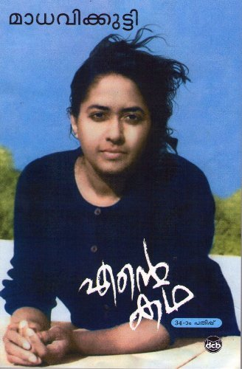

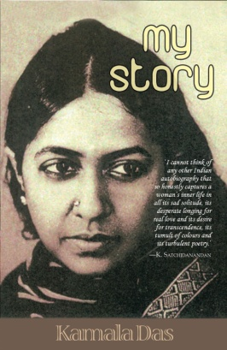

Kamala Das’s work has won much recognition and critical attention. She has received numerous awards, including the Sahitya Akademi Award in 1985. The critical reception of her work has been primarily through the lens of feminism, queer theory, autobiography studies, postcolonialism and modernism.

**Timeline**

1947 Publication of first short story

1949 Marries and moves to Bombay

1955 *Mathilukal*, first collection of short fiction

1965 *Summer in Calcutta*

1973 *Ente Katha*, autobiography in Malayalam

1976 *My Story*

1984 Contests and loses general election; *Collected Poems*, vol. 1

1999 Conversion to Islam

2009 *Ya Allah*

**Select Bibliography**

Madhavikkutty. (1982) *Madhavikkuttiyude Kathakal* (Madhavikutty’s Stories). Kottayam: D.C. Books.

Das, Kamala. (1977) *A Doll for the Child Prostitute*, New Delhi: India Paperbacks.

____. (1992)*Padmavati, the Harlot and Other* Stories, New Delhi: Sterling.

Das, Kamala. (2010) *The Kept Woman and Other Stories*. Pune: Om Books.

Das, Kamala. (1976) *My Story*, New Delhi: Sterling. (autobiography)

Madhavikkutty. (1973) *Ente Katha* (My Story), Trissur: Current Books. (autobiography)

_____. (1989) *Varshangalku Munpu* (Years Ago), Trissur: Current Books. (memories)

_____. (1993) *Neermathalam Pootha Kalam* (When the Neermathalam Blossomed),

Kottayam: D. C. Books. (memoir)

Das, Kamala. (1976) *Alphabet of Lust*, New Delhi: Orient.

Madhavikkutty. (1978) *Manasi* (Manasi), Thirunanthapuram: Prabhat Books.

*_____.* (1988) *Chandanamarangal* (Sandalwood Trees), Kottayam: Current Books.

Madhavikkutty. *Madhavikkuttiyude Novellakal* (Madhavikkutty’s Novellas), Kottayam: DC Books, 2006.

Das, Kamala. (1965) *Summer in Calcutta*, New Delhi: Everest Press.

­______.(1967) *The Descendants*, Calcutta: Writer’s Workshop.

______. (1973) *The Old Playhouse and other Poems*, Madras: Orient Longman.

Das, Kamala and Pratish Nandy. (1979) *Tonight, this Savage Rite: The Love Poems by Kamala Das and Pratish Nandy*, New Delhi: Arnold Heinemann.

Das, Kamala. (1984) *Collected Poems* Volume 1, Trivandrum: The Nava Kerala.

______. (1991) *The Best of Kamala Das*, ed. P P Raveendran. Kozhikode: Bodhi Books.

*______*. (1996)*Only the Soul Knows how to Sing: Selections from Kamala Das*, Kottayam: D.C. Books.

_____. (2009) *Ya Allah* (Ya Allah), Kozhikode: Islamic Publishing House.

_____. (1984) “Smoke in Colombo” *Collected Poems* Volume 1, Trivandrum: The Nava Kerala. 14

_______. (1996) “Anamalai Poems” *Only the Soul Knows how to Sing: Selections from Kamala Das*, Kottayam: D.C. Books. 136-141

Das, Kamala. (1996) “Composition”, *Only the Soul Knows How to Sing: Selections from Kamala Das*, Kottayam: D. C. Books. 24-33

Kamala. (1947/2009). “Stree” (Woman), *Bhashaposhini*. July. 34-35

Raveendran, P.P. (1993) “Of Masks and Memories: An Interview with Kamala Das,” *Indian Literature* 155. 145 -161

Chaudhury, Supriya. (2010) “Modernisms in India” in *The Oxford Handbook of Modernisms*, ed. Peter Brooker, Andrzej Gasiorek, Deborah Parsons and Andrew Thacker. Oxford: Oxford University Press. 942-960

George, Rosemary Marangoly. (2000) “Calling Kamala Das Queer: Rereading ‘My Story’”  *Feminist Studies* 26 (3). 1-34.

Harrex, S. C. and Vincent O’Sullivan, eds. (1986) *Kamala Das: A Selection with Essays on Her Work*, Adelaide: CRNLE.

Iqbal Kaur. (1995). *Perspectives on Kamala Das's Prose.* New Delhi: Intellectual Publishing House.

Nair, Sreedevi K., ed. (2012). *Ten Women Writers of Kerala: Short Stories and Interviews*, Delhi: SSS Publications.

Ramakrishnan, E. V., ed. (1994) *Sthree, Swathwam, Samooham: Madhavikkutty Padanangal*

Ramakrishnan, E. V., ed. (2011) *Madhavikkutty: Padhnangalum Rachanakalum*. (Madhavikkutty: Critical Studies and Writings). D.C Books: Kottayam.

Raveedran, P.P. (1994) “Text as History, History as Text: A Reading of Kamala Das’ Anamalai Poems,” *Journal of Commonwealth Literature*, 29:2. 47-54.

Weisbord, M. (2010). *The Love Queen of Malabar: Memoirs of a Friendship with Kamala Das*, Montreal: McGill-Queen's University Press.